# 

# 

# **EBS PRATICAL ANIKET THORAT**

# TASK 1. Created a instance and a Attach ebs volume

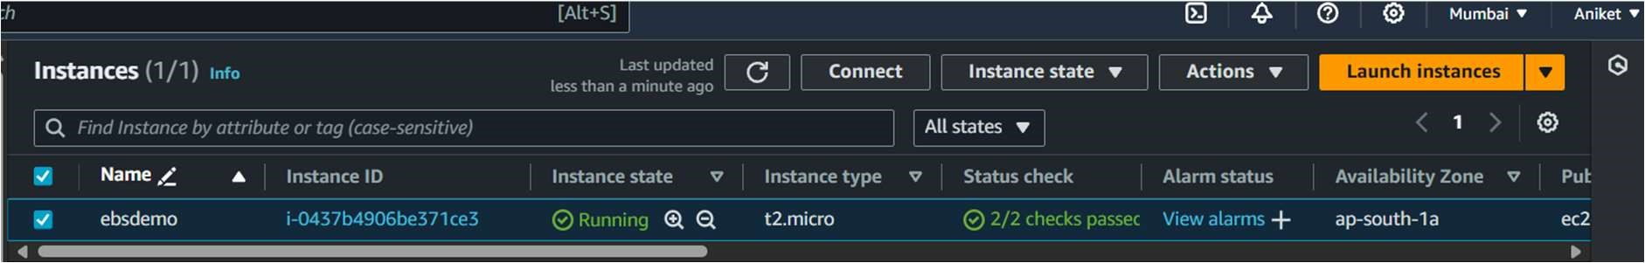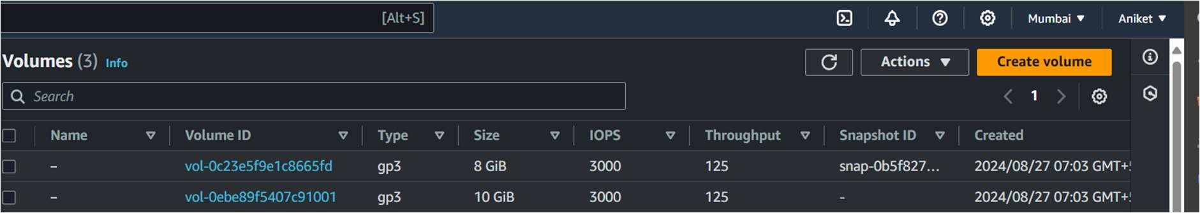

# ATTACH ROOT EBS TO INSTANCE

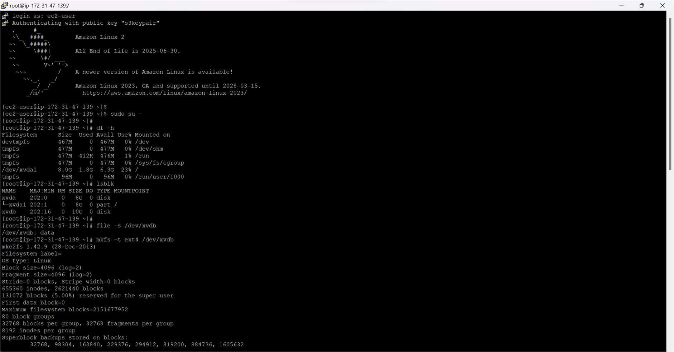

# TASK2. CREATE A SNAPSHOT FORM ROOT EBS

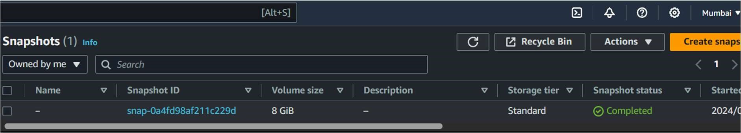

# CREATE A VOUME FROM SNAPSHOT

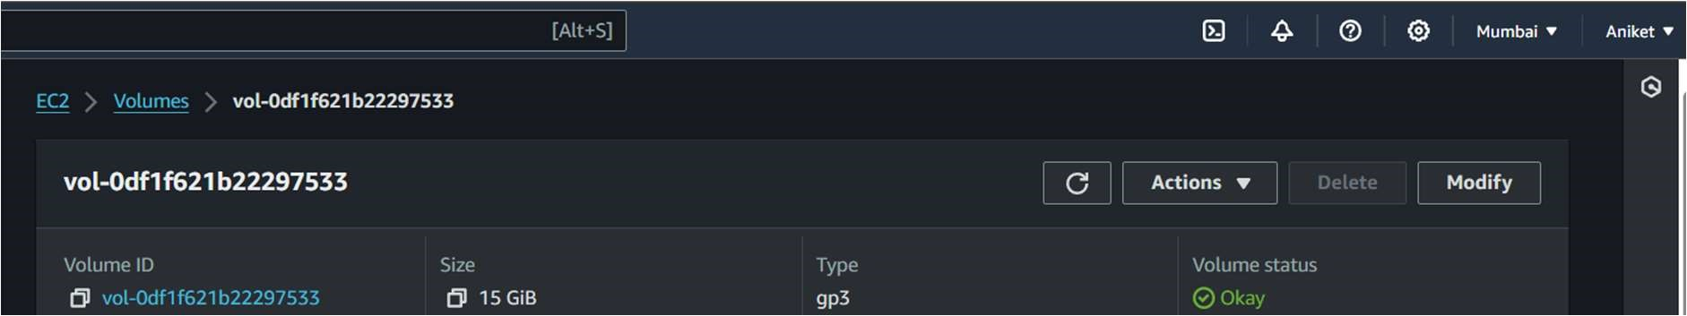

Stop the instance

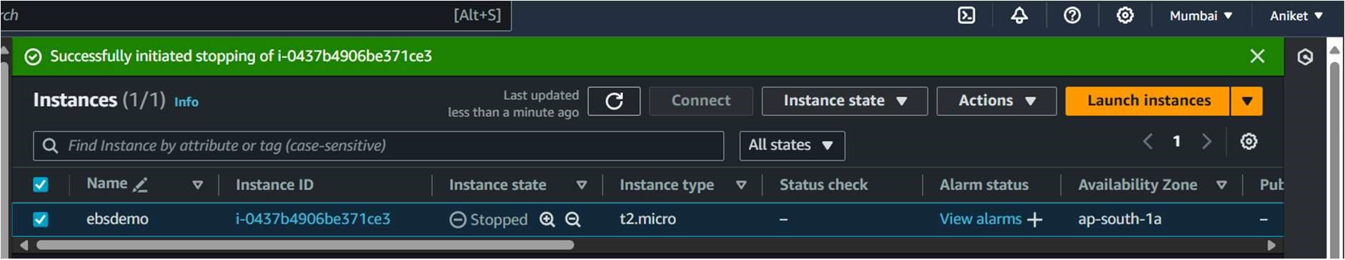

Detached the root ebs volume and a atched the ebs volume and now the root ebs vlolume is in the available state ( DETACHED)

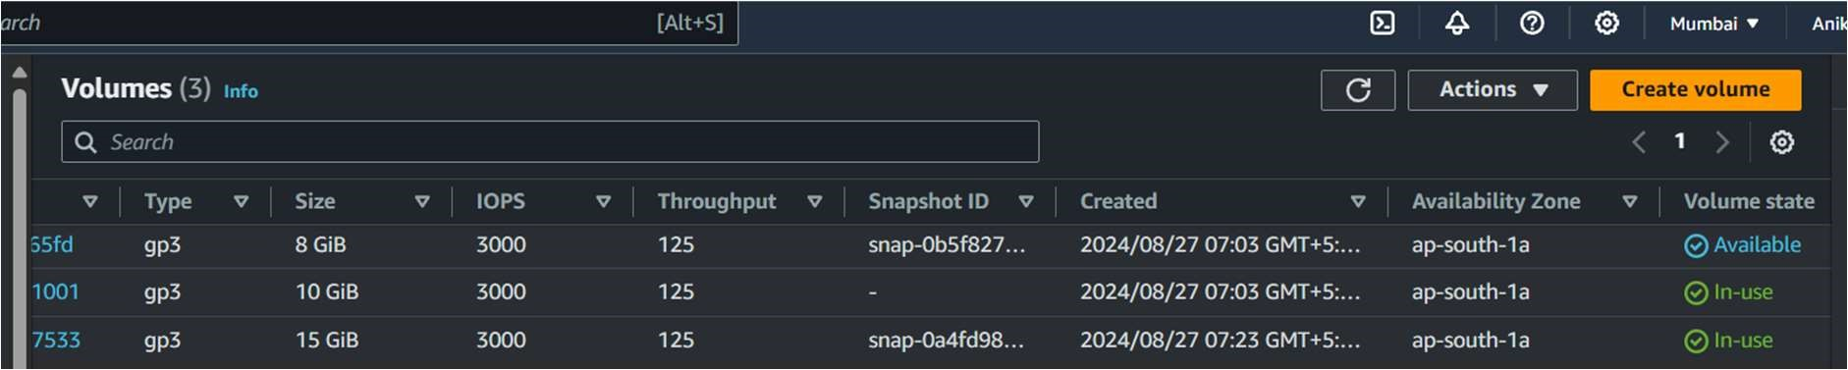

TASK 3 CREATE A NEW INSTANCE AND RESIZE THE EBS VOLUME

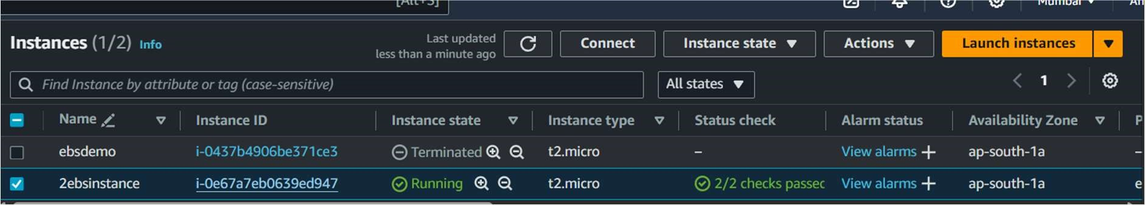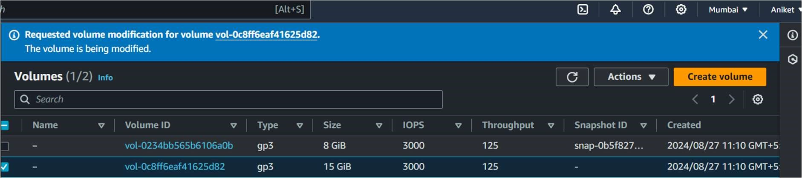

EBS VOLUEME RESIZED SUCCESSFULLY

